- Data entry, import, and basic organization using tables
- 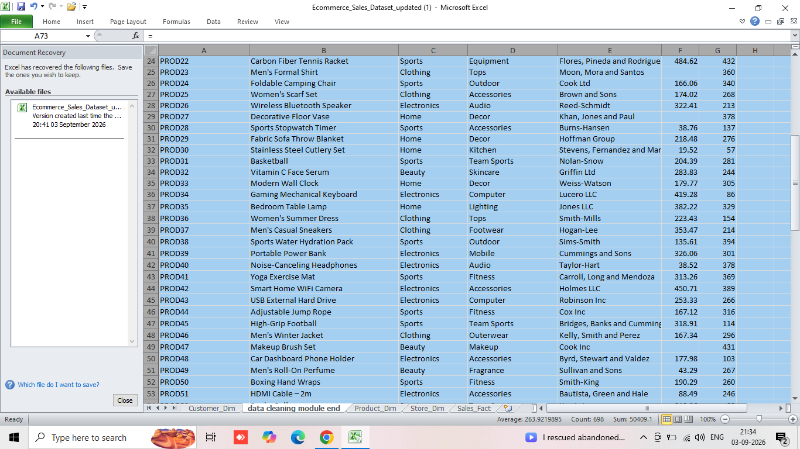
- Data cleaning: find/remove duplicates, handle missing/inconsistent data, correct formatting errors, and validate data
- 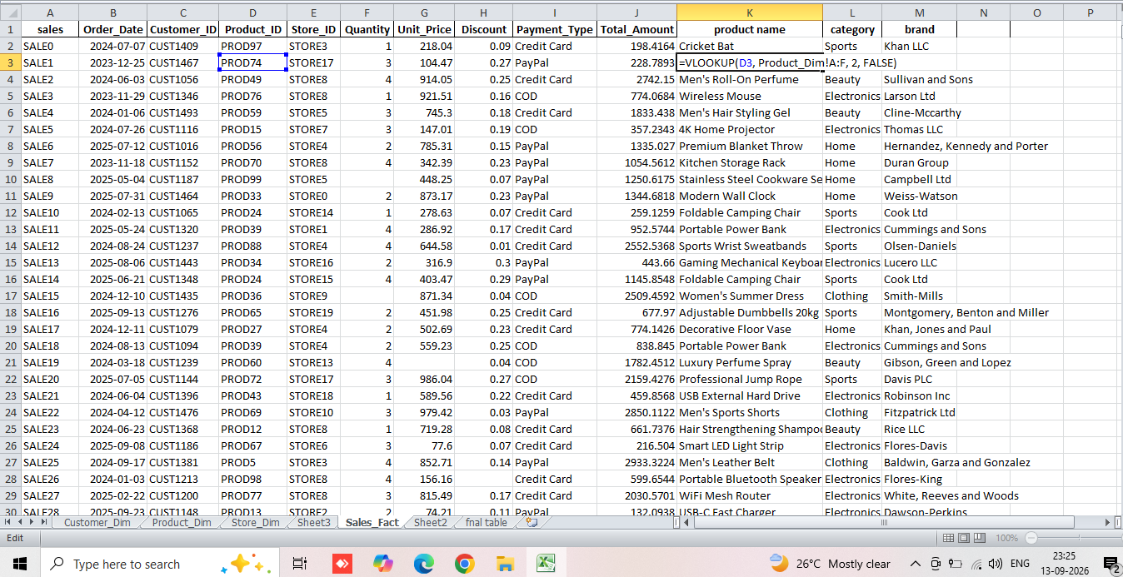
- Remove the column which contains irrelevant data(sub_Category)
- 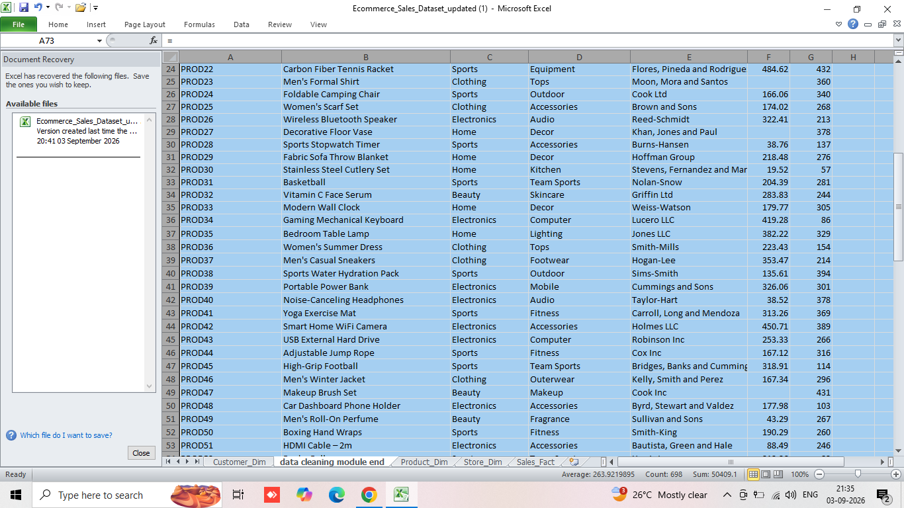
- Application of Excel formulas for calculations, summaries, and logical/text operations
- Use the XLOOKUP/VLOOKUP functions to combine the tables.
- 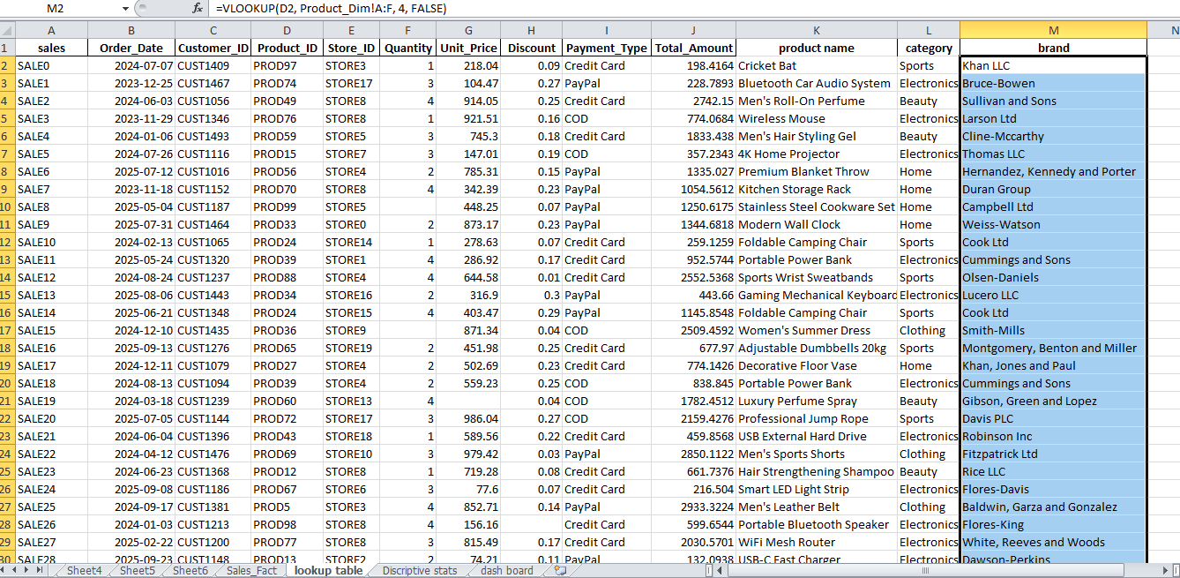
- Use of Pivot Tables for advanced summarization
- 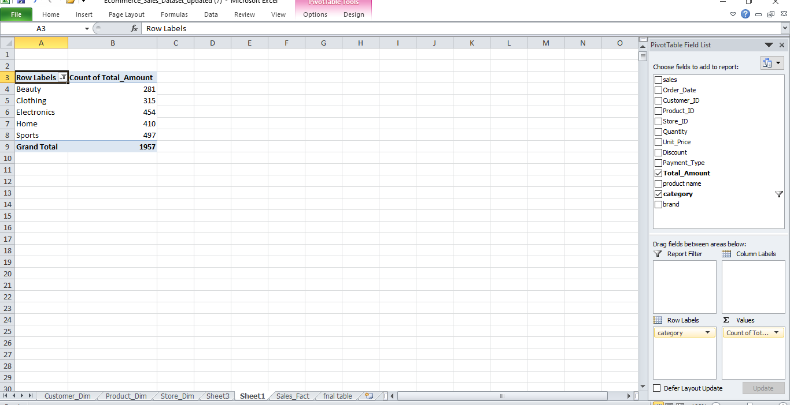
- Descriptive statistics (mean, median, mode, standard deviation, etc.) using formulas or Analysis ToolPak
- 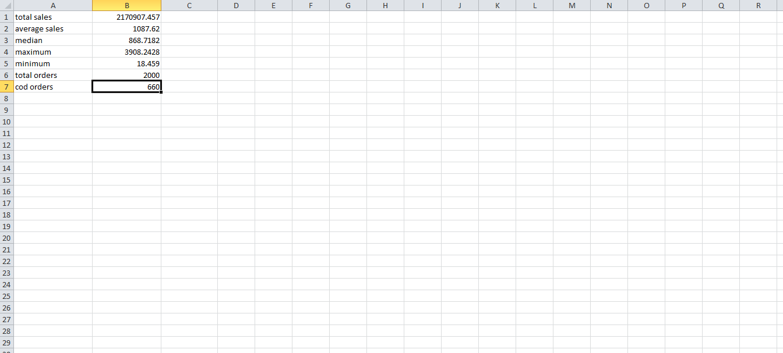

- Data visualization: create at least three chart types, build an interactive dashboard, and use basic PivotCharts
- 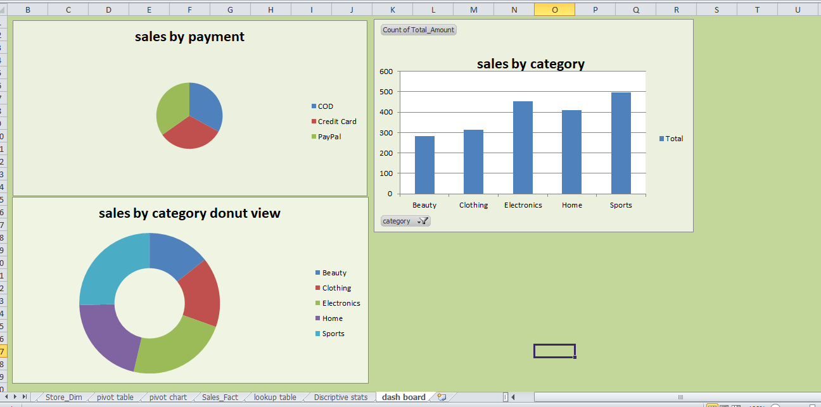

MODULE END ASSIGNMENT
SAMITHA PS
DA69

